**Protocol for operating Picarro analyzer (G2508)**

**Shutting down (when the instrument is running)**

Step 1: Click "stop cycle" in FRMonitor software, and click “Shut Down” .

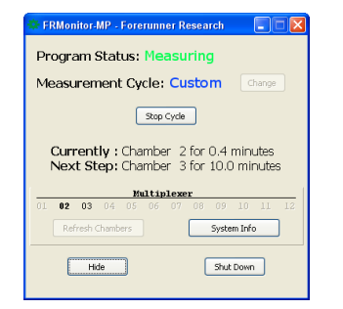

Step 2: In Picarro software, click "shut down", then select “shut down in Current State”. click ok

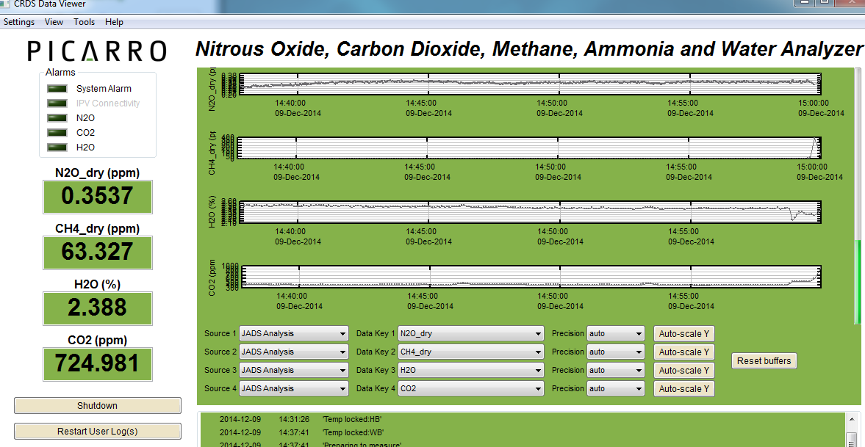

Step 3: Switch off Picarro Analyzer (Switch on back of unit)

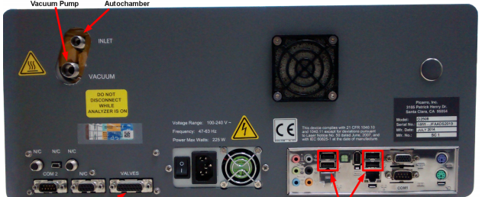

Step 4: switch off power strip and turn off the generator.

**Turning on**

**#1 If the generator shut down itself before you come:**

Step 1: Follow step 3 and step 4 from the instructions above, PLEASE turn off the picarro analyzer, power strip and the generator. PLEASE turn eco mode off on the generator.

Step 2: check gas for both the extended fuel tank and generator. Fill if necessary.

Step 3: If the body of the generator is cool off, turn on the choke and start the generator. Note: It is better to change the oil when the generator is warm.

Step 4: Turn off the choke after the generator runs, and then turn on eco mode. If the generator stops for more than 3-4 hours, you should wait 3 min to turn on eco mode.

Step 2: switch on power strip

Step 3: When pump turns on, switch Analyzer on

Step 4: Initialize Multiplexer

Step 5: Start measurement cycle from saved sequence